Letter of Invitation
This confirms the following competitor(s) have been accepted to compete at the Northern Ireland IPSC L3 Shotgun Championships 3-6 May 2018 in Scarva, Northern Ireland:

Competitor name: Nationality: Passport Number:
Firearm #1 - Make: Model: Serial Number:
Firearm #2 - Make: Model: Serial Number:

Competitor name: Nationality: Passport Number:
Firearm #1 - Make: Model: Serial Number:
Firearm #2 - Make: Model: Serial Number:

Competitor name: Nationality: Passport Number:
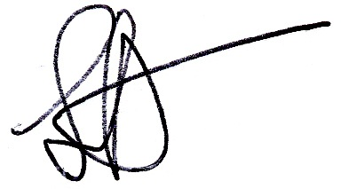
Firearm #1 - Make: Model: Serial Number:
Firearm #2 - Make: Model: Serial Number:

Competitor name: Nationality: Passport Number:
Firearm #1 - Make: Model: Serial Number:
Firearm #2 - Make: Model: Serial Number:

Competitor name: Nationality: Passport Number:
Firearm #1 - Make: Model: Serial Number:
Firearm #2 - Make: Model: Serial Number:

Competitor name: Nationality: Passport Number:
Firearm #1 - Make: Model: Serial Number:
Firearm #2 - Make: Model: Serial Number:

Signed on behalf of the Match Organising Committee,

Stephen Potts
Range Master

